AWS Task-1

Task Description:
Create a windows Vm machine in AWS and connect with RDP open CMD in windows share the about system info.
Tech stacks need to be used:
- AWS EC2 (windows)
Once launch the EC2 -> Select instance → Connect
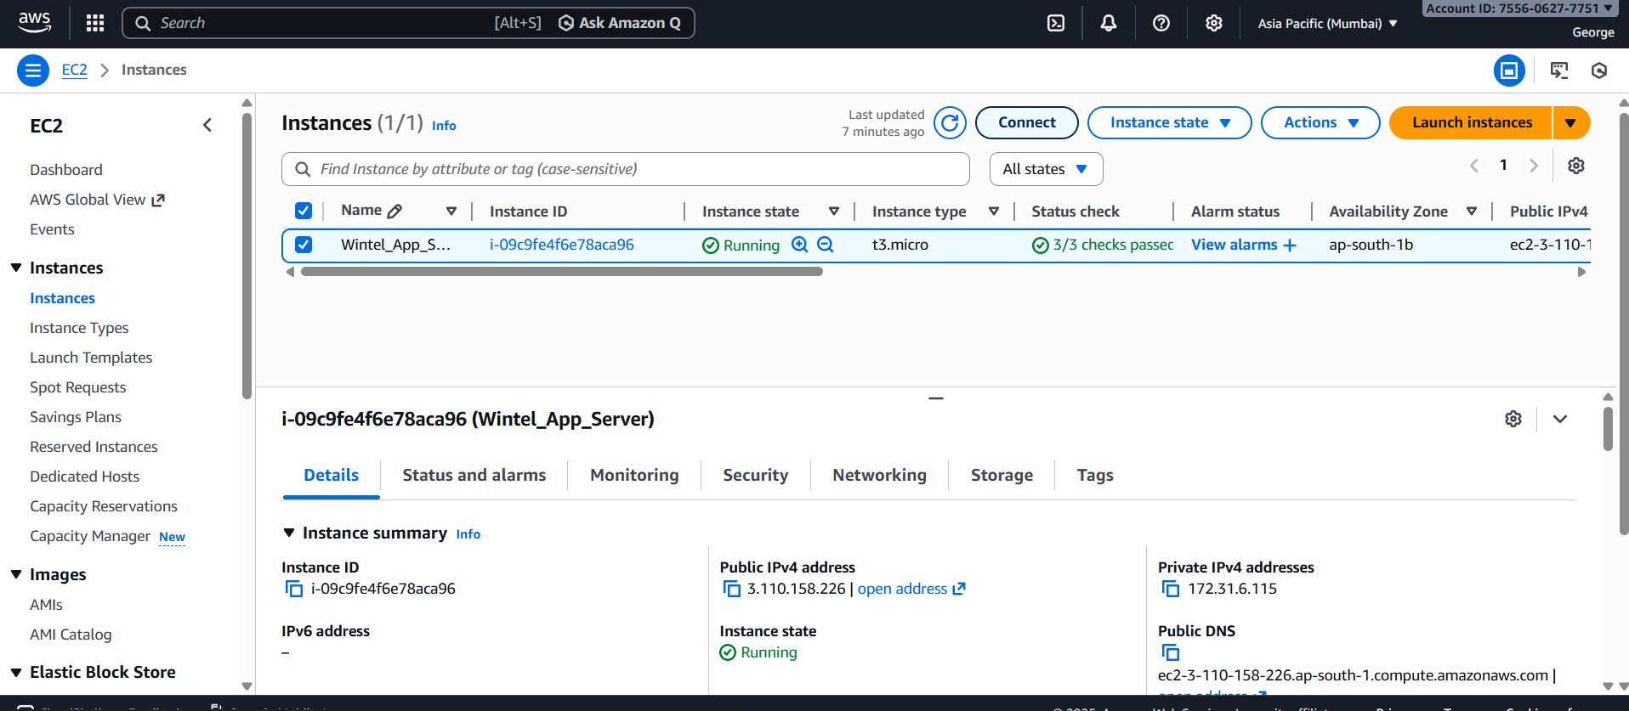

Choose RDP Client
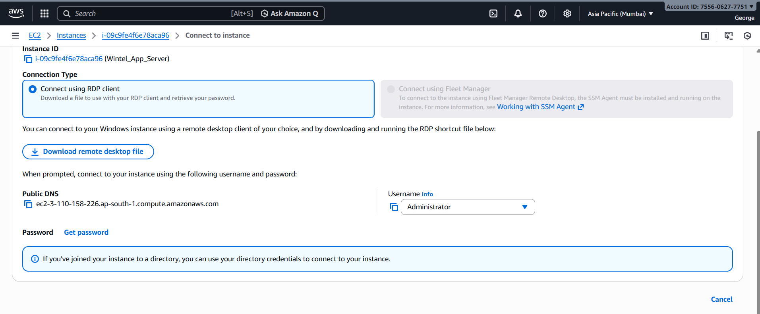

Click Get Password
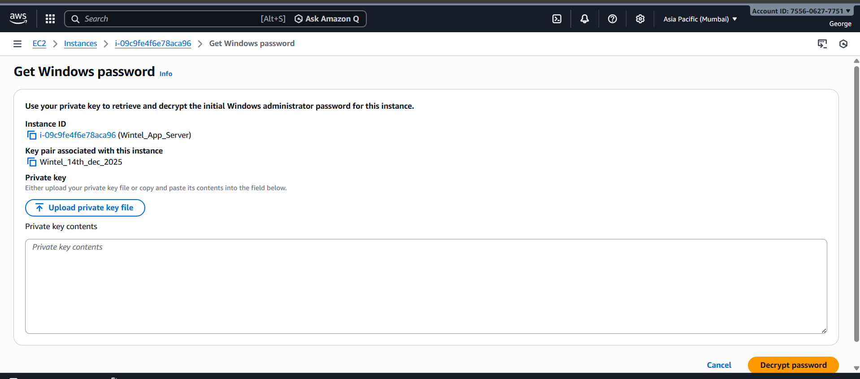
Upload your key pair (.pem file)
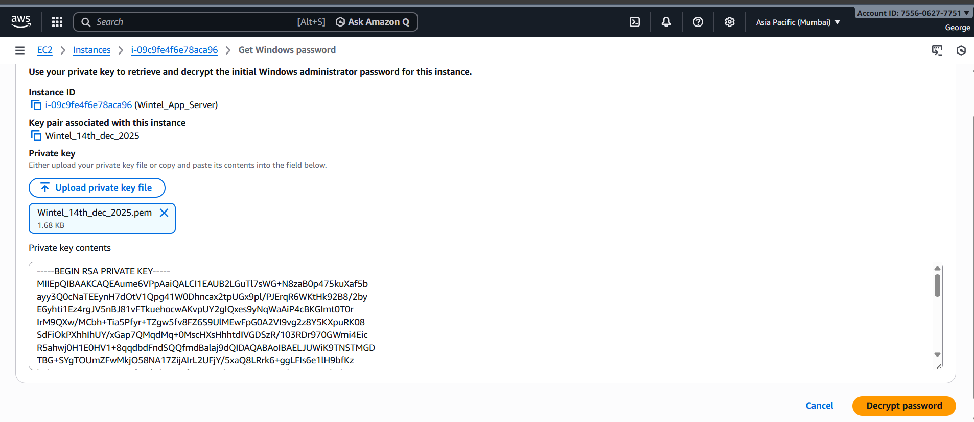
Decrypt the Administrator password
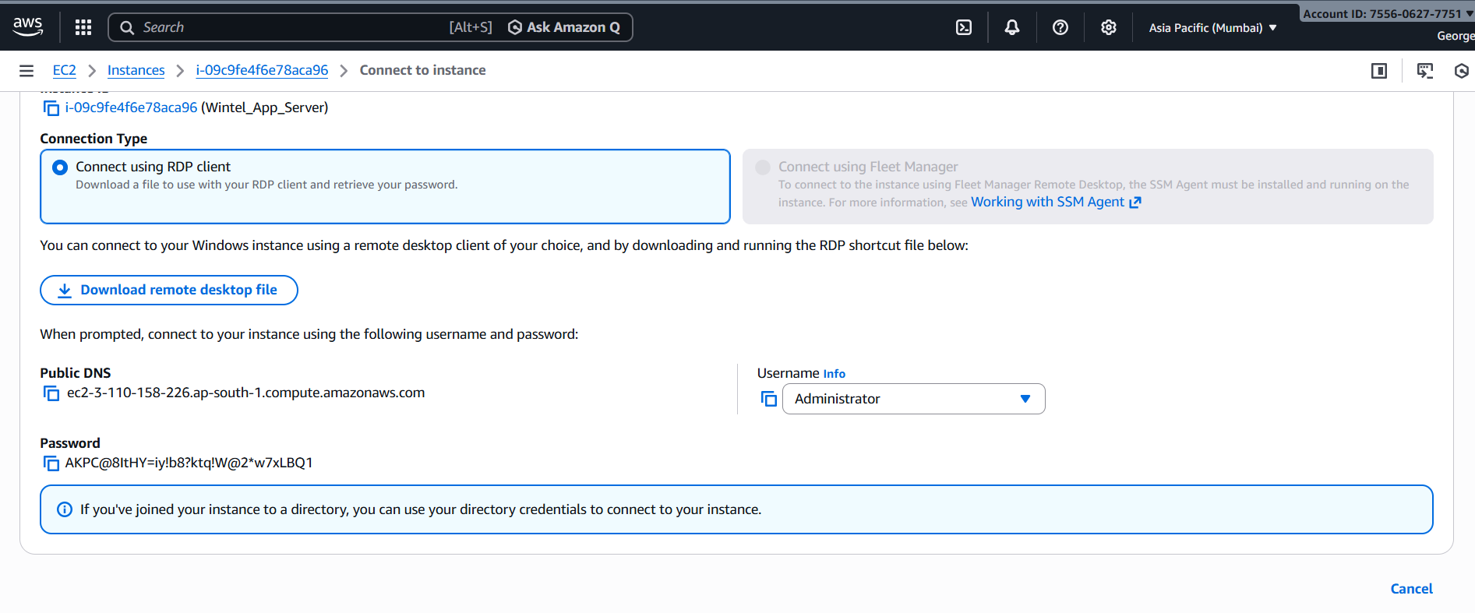
Copy the Administrator password and save it

- RDP (Preavailable in Windows)
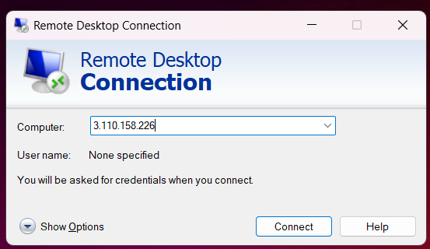

Username: Administrator
Password (decrypted)
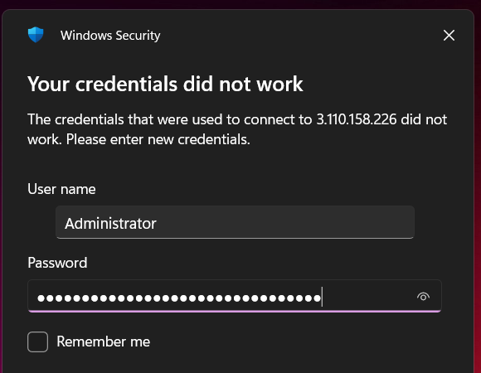

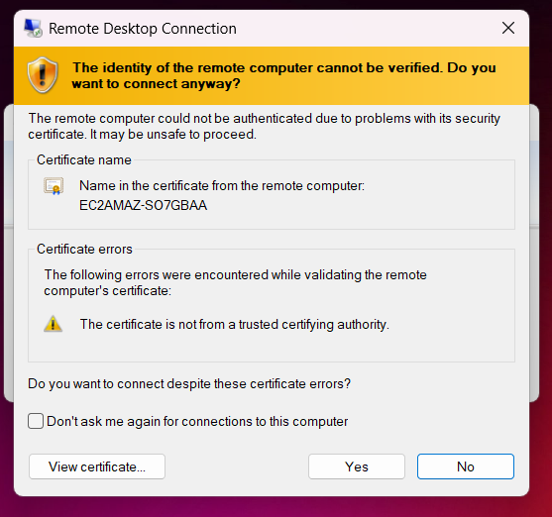

Launch Windows VM machine using pre-available RDP in windows
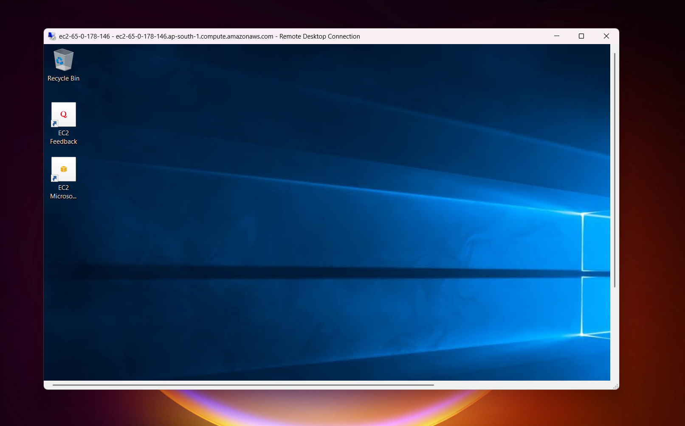

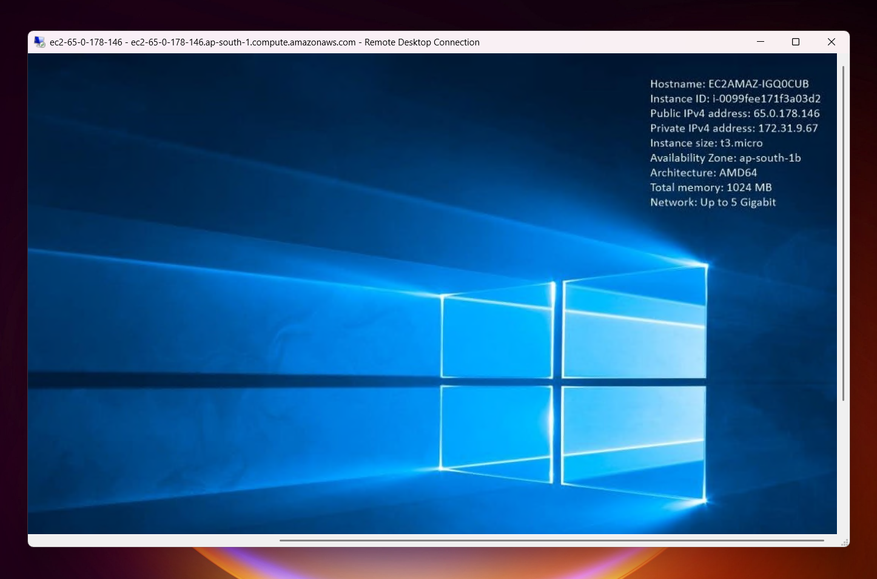

How do I submit my work?
- Push all your work files to GitHub (O/P screenshot images must).
- Submit your URLs in the portal.
Terms and Conditions?
- You agree to not share this confidential document with anyone.
- You agree to open-source your code (it may even look good on your profile!). Do not mention our company’s name anywhere in the code.
- We will never use your source code under any circumstances for any commercial purposes; this is just a basic assessment task.
NOTE: Any violation of Terms and conditions is strictly prohibited. You are bound to adhere to it.

